NIRMAYEE S. KADAM PRN-25070521134 SEC-C1
EXPERIMENT 4.1.1- SET OPERATION
ALGORITHM:
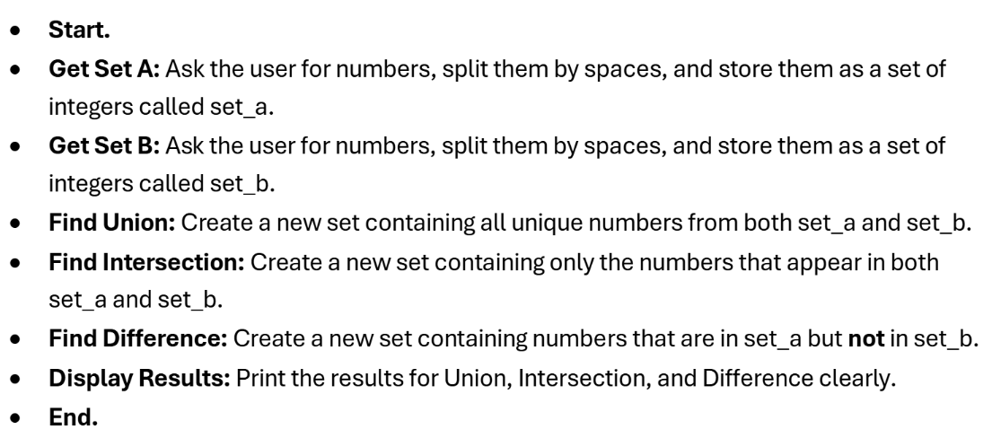

FLOWCHART:
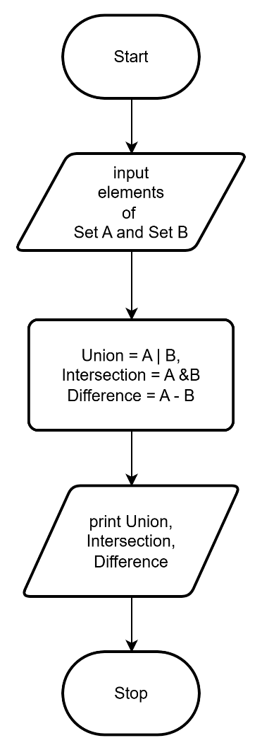
CODE:
